Clinical Interview Questions: Carbon Group
November, 2006: Developed by Jing Chen, Hui Jin, Valencia Moses, and Andy Anderson

1. Group question:
Prepare some separated pictures and each one shows a material on it as follows.
Initial question: Can you put these materials into groups in a way that would make sense to a scientist?
Possible follow-up questions:
- Can you explain why you made these groups? Do you have a name for each group?
- Can you think of any other ways that a scientist might group the materials? What would the names be for the new groups?

A scientist made three groups A, B, and C, as the following (arrange the pictures to show groups):
A. Sugar, meat, bread
B. Water, limestone, sand
C. Coal, gasoline, wood
What makes them grouped together? Can you think of names for the groups?
Why do you think that the scientist grouped water with limestone and sand rather than sugar and meat?
Does it seem to you that groups A and C have anything in common? If yes, what?
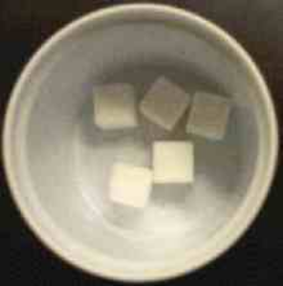
Sugar Meat Water

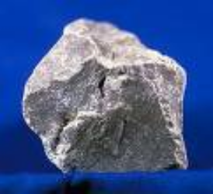
Limestone Sand Wood

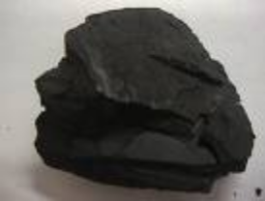
Bread Coal Gasoline
2. Needs of plants and animals question: Name the parts of a plant in the picture below. How does each of those parts help the plant survive?
Possible follow-up questions:
- What do the leaves do for the plant?
- Sometimes plants grow or turn their leaves toward the light. Do you know why they would do that?
What does the plant need to live and grow?
Possible follow-up questions:
- What does [named material] do for the plant? Do you know where it goes inside the plant?
- If students fail to mention water, soil (or minerals), or sunlight:
  - What about [water, minerals, or sunlight]? Do you think that the plant needs that?
  - What does [named material] do for the plant? Do you know where it goes inside the plant?


Now could you think about yourself and other humans:
What do we need to live and grow?
Possible follow-up questions:
- What does [named material] do for for people? Do you know where it goes inside the people?
- If students fail to mention water or food:
  - What about [water or food]? Do you think that the people that?
  - What does [named material] do for the people? Do you know where it goes inside the people?
Do you think that water is a kind of food for people? Why or why not?

3. Air question: [Ask only questions that were not covered in the discussion or people’s needs above]
Why do we need to breathe?
How do people use air? Where does it go inside us?
What is air made of?
Is there any difference between the air you breathe in and the air you breathe out? If yes, what are the differences?

4. Origin of food question: Where do the following foods come from? Trace the origin of the matter in these foods.
Possible follow-up questions:
- Where did the matter in (named source) come from?
- [See if the student can distinguish between questions about origins of matter and questions about growth. For example, some students will say that beef comes from cows and cows come from calves. Point out that the calves are small when they are born and they gain weight when they grow. Where does the weight that they gain come from?]

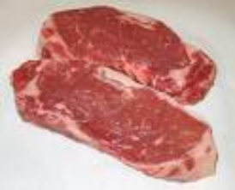

Cereal Beef Cheese

Or another related question, if there is no plant on earth, could any people still survive? Why?

5. Decomposer question: A tree falls down in the forest. Suppose nobody removes it away and no animals eat it. Then, tell a “scientific story” about what do you think will happen to the dead tree in the following years after it fell down?
Possible follow-up questions:
- What makes the tree rot? How does that happen?
- As the tree rots it loses weight? What is happening to the matter that was in the tree?

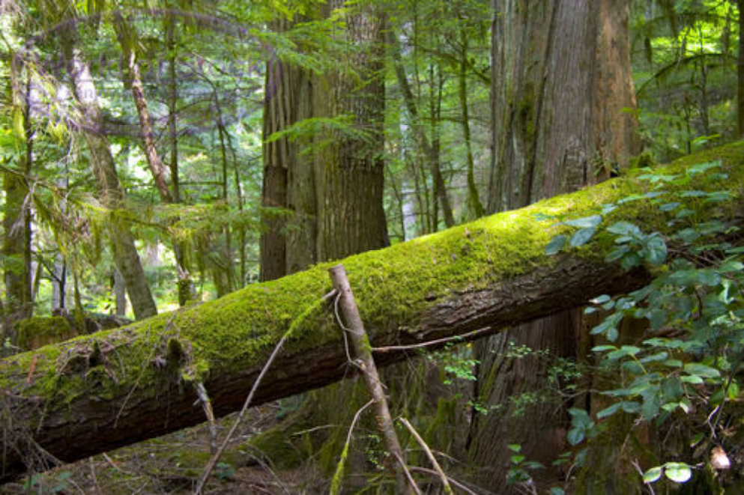

6. Combustion& Transportation question:
Why cars can not run without gasoline?
What does gasoline do in the car engine to help the car run?
Can cars run on water? Explain your answer.

Appendix

Sugar | Meat | Water
Limestone | Sand | Wood
Bread | Coal | Gasoline

Cereal | Beef | Cheese

